**Temperature influences on crab predation: an interesting consideration for biotic resistance to invaders  
Andy Stevens  
Sapelo 2015**

**Abstract**

Within aquatic ecosystems, biotic interactions are often complex and driven by predation. Abiotic factors have a profound influence on the degree to which these interactions occur and under certain circumstances, predation can provide a system with a mechanism of biotic resistance to invasion. Temperature has been hypothesized to play an integral role in shaping blue crab (*Callinectes sapidus*) predation on the invasive green crab (*Carcinus maenas*) along the Mid-Atlantic coast. We investigated how blue crab predation on mud crabs varied between sexes among three different temperatures ranging from 19oC to 30oC. Temperature was found to have an inverse relationship on time to consumption across the three temperatures, however this difference was only nearly significant (p=0.07). When aggregated across all temperatures, female had significantly lower time to consumption of mud crabs than males (p<0.02). When parsed by temperature group, this difference between sexes was only nearly significant at 19oC (p=0.06) and 22oC (p=0.07). While this inverse relationship between temperature and predation time occurred in the opposite direction as we hypothesized, these variables were still significant predictors of time to consumption according to our parsimonious model (p=0.01, 0.05 respectively, AIC=24.59). Literature suggests that the relationship between metabolism and energy intake is not a simple one and that blue crabs may possess a temperature buffering or compensation mechanism. While our study contained limitations that may have influenced the outcome, temperature and sex clearly have a role in shaping blue crab predation. Future studies are needed to assess the contributions these factors have in shaping blue crab biotic resistance along the mid-Atlantic coastline.

**Introduction**

The role of predation is integral in shaping community structure within aquatic ecosystems. Biotic factors such as predator abundance and species diversity can equip a system with biotic resistance to invaders (Herbold and Moyle 1986; Pimm 1989; Case 1991; Ross 1991; Baltz and Moyle 1993; Crawley et al. 1999; Stachowicz et al. 1999; Tillman 1999). In addition, abiotic factors such as temperature can determine predation pressure by dictating activity levels, feeding behavior and feeding rates among poikilotherms (Williams 1984, Bergman 1987, Hines et al. 1990). Along the mid-Atlantic coast, DeRivera et al. (2005) hypothesized that temperature and predation by blue crabs (C*allinectes sapidus*) operate synergistically to limit the distribution of the invasive green crab (*Carcinus maenas*).

The blue crab (C*allinectes sapidus*) is a highly sought after shellfish that provides substantial economic and ecosystem benefits (Baird and Ulanowicz 1993; NMFS 2013). Its range extends from Nova Scotia to Argentina. The green crab is a highly successful invader with established populations on five continents (Grosholz and Ruiz 2002). While the green crab has successfully colonized the entire Pacific coastline, its range along the Atlantic extends from Nova Scotia only to North Carolina. Within this range overlap, blue and green crabs share similar habitats and food items with the blue crab. While this dispersal limit may be due to a host of factors, blue crabs have been reported to provide biotic resistance thereby stemming the further spread of green crabs as they prey readily on them (DeRivera et al. 2005). Paralleling this notion of biotic resistance, Fofonoff et al. (2003) found no evidence of green crabs within Chesapeake Bay – a region with very high blue crab abundance. While green crabs would be expected to have colonized the Chesapeake Bay given their broad thermal tolerance, this was not the case.

The role that temperature plays in these specific instances has not been directly tested and is worth exploring (DeRivera et al. 2005). The thermal optima Cmax (grams prey consumed per gram wet weight) for blue crabs falls between 30oC and 32oC according to bioenergetic modeling (Brylawski and Miller 2003). As a poikilotherm, increased temperatures should result in increased metabolism rates and more active predation by blue crabs (Prosser 1973). Given that the blue crab is an opportunistic feeder and will voraciously predate on smaller crabs of multiple species, the role that temperature plays on predation can be examined in a laboratory set up (Hines et al. 1990; Clark et al. 1999). Here we explicitly tested the hypothesis that predation by blue crabs will follow a curve predicted by Brylawski and Miller’s (2003) bioenergetics model that is common to other poikilotherms. We investigated (a) how time to predation by blue crabs changes across three temperatures treatments and (b) if predation time differs by sex among blue crabs. We hypothesized that predation time will decrease with increasing temperatures and will be faster among females. The rationale for our second hypothesis comes from Fofonoff et al.’s (2003) findings of a sex specific distribution within Chesapeake Bay where females were found more abundantly near its mouth and males further up within its confines. This study may offer further incite as to how temperature gradients mediate predation and potentially provide evidence of the blue crabs biotic resistance in the context of the green crab invasion.

M**ethods**

***Study Site***

Sapelo Island is a barrier island off of the coast of Georgia and is home to the University of Georgia Marine Institute. The island is characterized by its productive salt marshes which are dominated by smooth cordgrass (*Spartina alterniflora*) and a robust marsh periwinkle population (Schelske and Odum 1961). These salt marshes are subject to inundation associated with strong diurnal tides of nearby tidal creeks that fluctuate approximately three meters twice a day.

***Crab collection***

From October 24th to October 27th, a total of n = 40 blue crabs were collected from Light House and Dean Creeks using standard two chamber 24” X 24” X 18” crab traps baited with a combination of beef liver, hot dogs and dead fish. The crabs were held in two 236 cm X 56 cm flow through tanks with a water depth of 15.25 cm. The tanks were aerated and had separate inflows of 22.4oC salt water from a common head tank that provided complete water replacement every 10 to 15 minutes. Tank 1 held crabs captured on October 25th and tank 2 held crabs captured from our second round of sampling on October 27th. This distinction was maintained to control the duration of starvation across trials as crabs captured in our second sampling round would be presumed to have eaten more recently in the wild than ones captured earlier. Male and female crabs were separated within each larger tank. To minimize variation in crab behavior, only undamaged individuals of approximately the same size (123.5 ± 3.78 mm carapace width) were used for each sex.

For a prey species, that would provide a green crab surrogate which are not present at Sapelo Island, mud crabs were used. The term “mud crab” is a loosely used blanket term for a variety of similar smaller marsh crab species, and the two species used during our trials were identified to be white clawed mud crabs (*Eurytium limosum*) and salt marsh mud crabs (*Panopeus obesus*). Mud crabs are eaten in the wild by blue crabs as they are generalist omnivores (Hines et al. 1990; Clark et al. 1999). Mud crabs were collected primarily from a side creek perpendicular to Light House Creek located just behind the housing unit and also from the Dean Creek Marsh. We collected mud crabs via standard minnow traps with modified openings that were baited with a mix of beef liver and hot dogs. However, a more efficient method was later discovered which involved inserting a small pvc pipe into one end of a mud crab’s U-shaped tunnel and forcing them out the other end (Appendix A). Mud crabs were stored in an aerated 15 gallon tank at ambient temperatures (22.4oC). Carapace widths were all 25.75 ± 5.2 mm and were measured using a standard dial gauge caliper.

***Laboratory aquarium experiments***

To attempt to evaluate temperature dependence of blue crab predation on other crabs, three different temperatures were used for predation trials (19oC, 30oC, and an ambient temperature of 22.4oC). These temperatures were chosen because they provide a wide thermal range that is representative of three points of interest across the green and blue crab’s geographic distribution. Specifically, average maximum July water temperatures (assumed to be season for peak thermal activity) observed from NOAA’s real-time instruments come close to our induced temperatures in the Boston Harbor, MA (19.4oC), an area where green crabs are outcompeting and displacing blue crabs, at Savannah Beach, Georgia (30oC) where only blue crabs exist and in the Chesapeake Bay entrance (22.3oC) where overlap should occur but is not.

By utilizing three 250 watt aquarium heaters and two aerators for circulation, I was able to raise and maintain the water of a 236 cm X 56 cm tank at 30oC. Two 22.7 L aquaria were placed within this larger holding tank in which the trials were conducted. In addition, four male and four female blue crabs were placed in the larger tank once the water reached equilibrium for an acclimation time of 12 hours prior to predation trials.

A mass balance equation was used to calculate the amount of ice (30.5 gallons) needed to bring ambient water in our holding tank to an equilibrium of 19.0oC. Because this ice diluted the salinity of the overall holding tank, blue crabs were instead held in the two smaller aquaria (2 crabs in each tank separated by a sub divider) for the 12 hour acclimation period prior to predation trials. This was repeated twice.

***Predation trials***

In each trial, simultaneous observation of two side by side 22.7 L aquaria containing 15.25 cm of water, an aeration stone and no sand was made for two hours. A cardboard barrier was placed in-between tanks during the ambient trials and an aeration bubble barrier was placed between tanks during the 19oC and 30oC trials for cross tank visibility influence within their larger holding tank. We specifically avoided using sand because it would have to be entirely replaced after each trial to avoid olfactory predatory influence on the next trial. To avoid disturbance, a GoPro camera was used to film each predation trial. Beginning and ending water temperature, trial time, crab size (mm) and the number of crabs consumed were recorded during each trial (Table 1).

In each tank, one blue crab was paired with two mud crabs. Predation was measured as time to consumption for our dependent variable. This was determined as the time in which the blue crab successfully captured and started consuming a mud crab. Four males and four females were observed at each of the three temperatures groups. Time to consumption was our dependent variable and was recorded as the moment when the first mud crab was captured by the blue crab. The term “time to consumption” is arbitrary as the actual consumption of the mud crab had a prolonged duration. Despite observing consumption of two mud crabs in 11 of the trials the time to consumption of the second crab is not independent of the first due to capture time and satiation among larger statistical assumption violations. Therefore only the first capture event was recorded.

***Statistical Analysis***

Consumption data were analyzed using RStudio (2015) for analysis of variance (ANOVA) and covariance (ANCOVA) and for graphing and proportions testing. Time to consumption was log10 transformed to meet the normality assumption for parametric testing. Normality and homoscedasticity were confirmed for variables by using Shapiro-Wilk and Levene’s tests. To examine whether blue crab time to consumption varied across our three temperature trials, and sex, an ANOVA model was determined by first fitting a full model including all covariate factors (sex, blue crab size, mud crab size) and then parsimoniously reducing the model based on significance of factors.

**Results**

***Test subjects and tank conditions***

The size of the 24 blue crabs used ranged from 120 to 132 mm carapace width and a mean of 123.5 mm (± 3.78 SD). The range of mud crab sizes ranged from 19 to 39 mm carapace width and a mean of 25.75 (± 5.2 SD). Within each temperature group, the averages were 19.3oC (± .13 SD), 22.5oC (± .21 SD), and 29.8oC (± .25 SD).

In the predation experiments, blue crabs ate 29 of the mud crabs (60%). Among the three temperature groups, the total number of mud crabs consumed was not statistically different (prop test X2 = 1.22, p=0.54) nor was the number of blue crabs that consumed both mud crabs during a trial (prop test X2 = .34, p=0.85). However, this small Chi-squared value did merit a warning as with this small sample, small changes could have a big effect. The number and time that consumption occurred can be viewed in Appendix B.

***Time to consumption***

Normality and homoscedasticity were assessed using Shapiro Wilks and Levene’s Test. A log transformation of time to consumption allowed the data to meet the assumptions of parametric statistics (Shapiro Wilk p=.88 and Levene’s p=0.83).

Log time to consumption was statistically significantly different between males and females when all temperature groups were considered together (Welch Two Sample t-test p=<0.01). An ANOVA revealed a near significant difference in blue crab time to consumption among temperature groups (p=0.07)(Figure 1 left panel). When separated by sex, females appear to have a lower time to consumption than males at each temperature group (Figure 1 right panel). When tested, this difference was nearly significant between males and females at 19oC (p=0.07) and at ambient temperature (p=0.06).

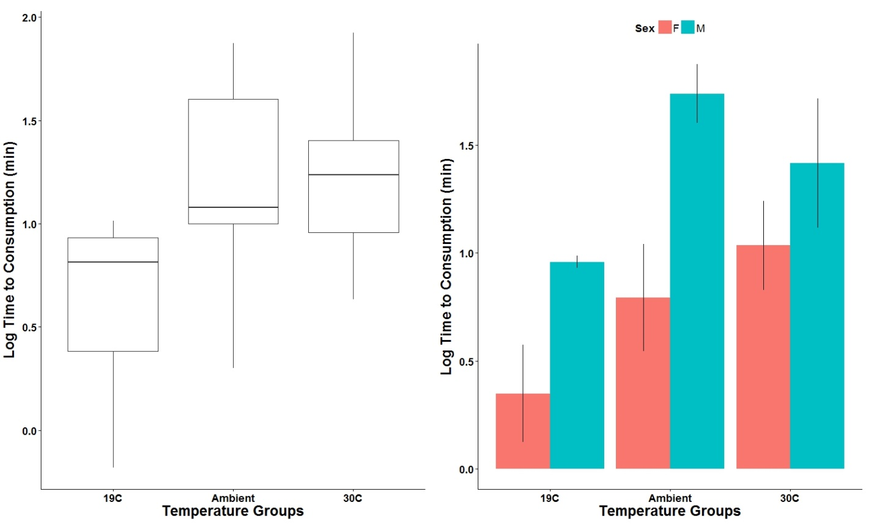

**Figure 1**. The left panel displays median log transformed time to consumption (min) at each temperature group. The right panel shows the same data when separated by sex. Error bars represent ± 1 standard error of the mean.

Time to consumption was investigated between both sexes across temperature and blue crab size (Figures 2 and 3). ANCOVA revealed that while both temperature and sex had a significant effect on log time to consumption (p=0.04 and <0.01), no significant interaction occurred between the two (p=.47). The regression line of males intercepts the y-axis at a higher value than for females indicating a comparative prolonged time to consumption across temperatures. The non-significant interaction indicates that the slope of regression between temperature and log time to consumption is similar for both males and females (Figure 2).

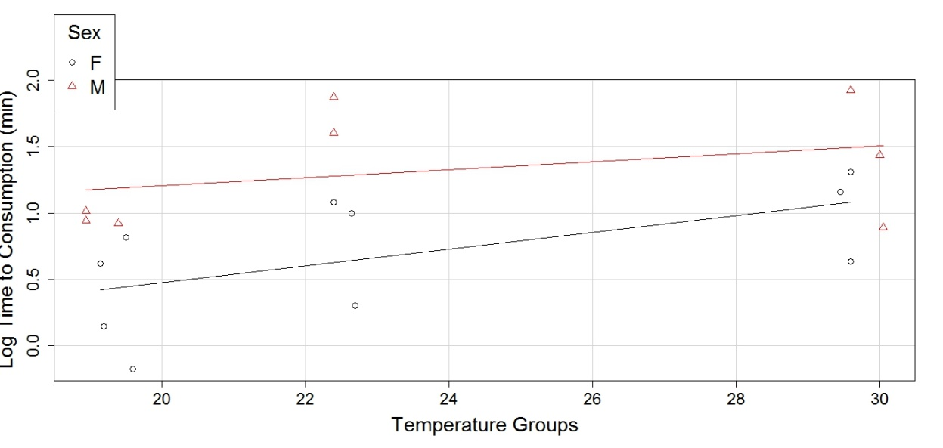

**Figure 2.** Log time to consumption plotted against all three temperature groups and sorted by sex.

***Crab size***

Mud crab size was found to be slightly correlated to time to consumption (R2=0.33)(Figure 3). However, when only females are considered, this correlation increases (R2=0.47). An ANCOVA test showed that mud crab size was not significant when included in our model (p=0.11) and that no significant size*sex (p=0.59) nor size*temp interaction occurred (p=0.22). 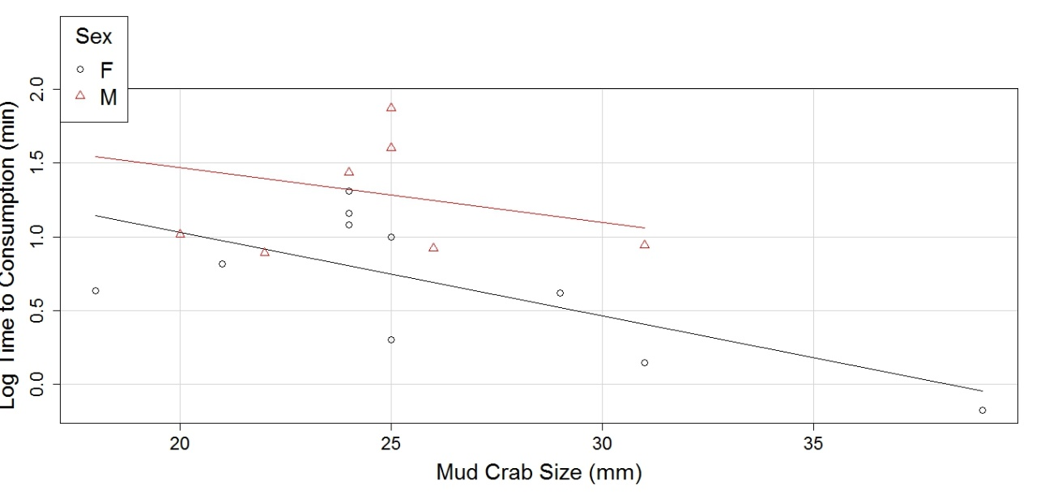

**Figure 3.** Log time to consumption plotted by mud crab size and sorted by sex. Least squared lines are plotted by sex. An overall least squares line gives an R2=0.33 however females alone were R2=0.47).

The ratio of blue crab size to mud crab size was calculated and was slightly correlated to time to consumption (R2=0.22). Finally, not correlation was found between blue crab size and time to consumption (R2=0.02) nor was it significant when included in the model (p=0.84) or as an interaction with sex (p=0.22).

To verify the significant of each parameter mentioned above in predicting blue crab time to consumption, an ANOVA model was fit using utilizing the glm function in R. The full model included log time to consumption as the dependent variable and all other covariates (temperature group, sex, mud crab size, blue crab size,) as explanatory variables. The full model yielded an AIC of 25.04. The strongest parsimonious ANOVA model was: Log time to consumption ~ temperature + sex + mud crab size which yielded an AIC of 24.59 (Figure 4). These coefficients can be interpreted as: increasing temperature by 1oC results in a 0.04 minute increase in log time to consumption while holding sex constant.

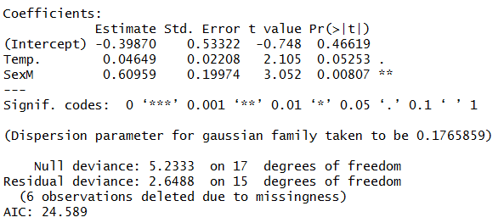

**Figure 4**. Rstudio output for the final model LogTC~ temp group + sex.

**Discussion**

***The role of temperature on predation***

Our final model indicates that temperature and sex are significant terms in predicting time to consumption. In viewing Figure 1 and 2, it can be seen that as temperature increases, so does time to consumption. The right panel of Figure 1 shows higher time to consumption at each temperature group for males, however this sex difference was only near significantly different at 19oC (p=0.07) and at ambient temperature (p=0.06). No significant interaction was observed between sex and temperature and Figure 2 reveals similar regression slopes with the regression line of males intercepting the y axis at a higher value than for females. This indicates a comparative prolonged time to consumption (Figure 2). This trend of decreasing time to consumption with decreased temperature was the opposite of our prediction based on expected trends from a bioenergetics standpoint. We offer a host of potential explanations below.

It is a rudimentary biological concept that feeding rate and metabolism are closely intertwined. However, the relationship between metabolism and energy intake is not a simple one (Salazar et al. 1987). Wallace (1973) found that shore crabs (*Celenius maenas*) acclimated at 24oC ate 2.4 times as much food than at 10oC but metabolic levels only differed by a factor of 1.4. Wolvekamp and Waterman (1960) concluded that some crustaceans possess the ability to alter their metabolic rate thus, allowing them to optimally function at low temperatures. Leffler (1972) reported that the rate of metabolism in blue crabs does not passively follow ambient temperature, rather a degree of acclimation occurs within 4 weeks at all temperatures tested. When blue crabs were introduced to a higher temperature than they were acclimated to, their metabolism extended above those who were acclimated to those temperatures. Conversely, crabs exposed to temperatures below their acclimation temperature did not show an immediate fall in metabolism levels to that below crabs acclimated to those temperatures. Specifically, crabs acclimated at 20oC had higher metabolism rates when exposed to 13oC water than crabs acclimated to that temperature.

This temperature/metabolism buffering mechanism supplies evidence of why time to consumption did not vary significantly among temperature groups. Leffler’s (1972) study reported that between 20oC and 27oC, blue crabs maintain near homogenous metabolism and compensate beyond that. While our blue crabs were held in the temperature they were sampled from (22.4oC), they likely also maintained a near homogenous metabolism across the three temperature groups were exposed them to given the short (12 hour) acclimation duration.

In addition, the temperature difference was much larger for crabs going from ambient holding tanks to 30oC (change of 7.6oC) versus crabs going from the ambient water to 19oC (change of 3.4oC). Lieffer (1972) reported that when exposed to 34oC, the O2 consumption rate (an indicator of metabolism) of crabs acclimated to 27 oC water were much higher than that of crabs acclimated to 34oC - an incomplete compensation. Along these lines, it is possible then that our crabs exposed to 30oC, were exhibiting higher than expected metabolism rates. While it is unlikely that our crabs were approaching their CTMax (an index of organism heat tolerance) at 30oC, this over compensation mechanism and large temperature jump could have induced stress resulting in higher time to consumption.

Secondly, the lower time to consumption in our 19oC trials may be explained by the smaller enclosures these crabs were tested in. Cooling the holding tank from ambient temperature to 19oC involved adding a large proportion of ice which decreased the salinity of the overall water. To prevent this from harming or biasing the blue crab behavior, they had to be placed within the two smaller trial tanks during acclimation time. While this protected them from the diluted water, it reduced the number of crabs we could acclimate at once. Given that we wanted to maintain a consistent sample size across all temperature groups (n=8), the lengthy 12 hour acclimation time, and limited resource constraints, we placed two blue crabs in each smaller tank (separated by a glass divider). We were able to repeat this process twice to reach our desired sample size. The trials were conducted in these smaller (halved) enclosures and it is possible that these blue crabs were able to successfully locate and capture mud crabs more opportunistically.

***Males/females differences***

Sex was found to be a significant model parameter in determining time to consumption. Females always on average had a lower time to consumption when all groups were compared together (p=0.03). This difference is evident in viewing Figures 1 and 2.

While the difference in their regressions intercepts was slim, it is worth noting that many of our crabs when placed into a larger undivided holding tank after trials were completed exhibited mating behavior. Both direct mating positions and behavior (males waving of swimmerets at females) were observed. This “mating” position we observed is one that has been described to be a protection “cradle-carry” position the male exhibits after mating (Van Engel 1958; Gleeson 1980; Johnson 1980). One particular behavior observation occurred in a pre-trial where adjacent tanks were not separated by a cardboard divider nor differentiated by sex. In this trial the male could see the female in the adjacent tank and seemed more interested in her than eating mud crabs. Male crabs mate multiple times while females mate only once (Millikin and Williams 1984). While this varying male behavior/consumption could be due to triggered spawning instincts, it is likely that the spawning season was already over for females. However, Tagatz (1968a) observed ovigerous females in Florida waters as late as October.

***Prey size***

One potential issue is the consideration of size preference by blue crabs due to handing times. In the presence of multiple conspecifics, handling time could bias the selection decision – a blue crab might consume the smaller conspecific first to get to the larger one more quickly. Griffiths (1975) suggests a bidirectional take on optimal foraging: energy maximizers and number maximizers. Shore crabs (*Carcinus maenas*) have been found to select a prey size (cockles) well below the maximum size they are capable of consuming due to energy maximization and potentially mechanical characteristics of the chelae (Salazar et al. 1987). A past study done at Sapelo Island by Johnson (1991) suggests that blue crabs are energy maximizers – they preferentially select higher energy prey items. Although mud crab size was nearly a significant factor (p=0.11), the difference in intercepts and homogeneity in regression slopes seen in Figure 3 indicate that larger crabs were consumed faster. This regression trend was particularly evident among females (R2=0.47). Due to limitations of the number of mud crabs available, we could not specifically choose which sized mud crabs were given to blue crabs for a given trial; rather they were used on an as caught basis. While larger blue crabs can easily handle both large and small mud crabs, it is possible that handling time was limited for smaller blue crabs although our results did not support this as ratio was not a significant variable.

**Conclusion**

The role of temperature is interesting to consider in shaping the limited geographic distribution of green crab along the Mid-Atlantic coast. As DeRivera et al. (2005) suggested, this may be due to a synergistic effect of both predation pressure and temperature. While our results confirm the role of temperature as a significant behavior in predicting predation outcomes, it was in an unexpected direction. Literature indicates complication in the relationship between metabolism and consumption and blue crab metabolic regulating mechanisms may further complicate this relationship. Sex was also found to be a significant predictor in blue crab time to consumption. It is indeed possible that a combination of induced stress during the 30oC trials due to metabolic overcompensation mechanisms and smaller enclosure sizes during the 19oC trials influenced the direction of our results. Future studies that mitigate the limitations of this study are needed to further investigate the role temperature has on predation. This should be done by strictly maintaining conspecific crab size, keeping trial enclosure sizes consistent and by testing more extreme temperature variations. Given the biased behavior that can occur in lab observational test, field studies investigating the relationship between temperature and predation could also prove useful. While temperature seems to play a significant role in mediating blue crab predation, this relationship and how it relates to biotic resistance of green crabs on the Atlantic coast merits further study.

**Notes to future Saploidians:**

***Dear future scholars and Georgian beach goers, I hope you can learn from this study. See appendix A for methods on removing mud crabs from their burrows. I found them in highest densities near the side creek on Dean Creek Marsh and at the die back site on the bank of Dean Creek Marsh (look for larger holes). If you are worried about handling blue crabs during lab trials (as you should be), I found that a barbeque tongs with duct tapped tips (so the crabs don’t slip) was an effective way to handle them. If you attempt to do a similar study, I recommend planning to set your temperature settings which are furthest from ambient ahead of time. Also, for trapping blue crabs, the best location was the second dock down from the Light House Creek dock. The locals used dead fish as bait and that seemed to work well. Plan everything out well ahead of time and make sure in-between trials to take in the scenes during this truly, once in a lifetime opportunity.***

**References**

Baird, D. and R. E. Ulanowicz. 1993. Comparative study on the trophic structure, cycling and ecosystem properties of four tidal estuaries. Mar. Ecol. Prog. Ser. 99(3): 221-237.

Baltz, D. M., & Moyle, P. B. (1993). Invasion Resistance to Introduced Species by a Native Assemblage of California Stream Fishes. *Ecological Applications*, *3*(2), 246–255. http://doi.org/10.2307/1941827.

Bergman, E. 1987. Temperature-dependent differences in foraging ability of two percidsPerca fluviatilisandGymnocephalus cernuus. Environmental Biology of Fishes19:45–54.

Brylawski, B. J., and T. J. Miller. 2003. Bioenergetic modeling of the blue crab (*Callinectes sapidus*) using the fish bioenergetics (3.0) computer program. Bulletin of Marine Science 72(2):491-504.

Case, T. J. 1991. Invasion resistance, species build-up, and community collapse in metapopulation models with interspecies competition. Biological Journal of the Linnean Society42:239–266.

Clark, M. E., T. G. Wolcott, D. L. Wolcott, and A. H. Hines. 1999. Foraging and agonistic activity co-occur in freeranging blue crabs (Callinectes sapidus): observation of animals by ultrasonic telemetry. Journal of Experimental Marine Biology and Ecology233:143–160.

Crawley, M. J., S. L. Brown, M. S. Heard, and G. R. Edwards. 1999. Invasion resistance in experimental grassland: species richness or species identity. Ecology Letters2:140–148.

DeRivera, C. E., Ruiz, G. M., Hines, A. H., & Jivoff, P. 2005. Biotic resistance to invasion: native predator limits abundance and distribution of an introduced crab. *Ecology*, *86*(12), 3364-3376.

Fofonoff, P.W., Ruiz, G. M., Steves, B., Hines, A.H.; Carlton, J. T. 2003. National Exotic Marine and Estuarine Species Information System: Chesapeake Bay Introduced Species Database: http://invasions.si.edu/nemesis/chesapeake.html.

Gleeson, R., and J.F. Gerard. 1974. Amino-acid metabolism during osmotic stress in isolated axons of *Callinectes sapidus*. Life Sci. 14:1221-1229.

Grosholz, E. and G. Ruiz (editors). 2002. Management Plan for the European Green Crab.  Aquatic Nuisance Species Task Force.  55 pp.

GRIFFITHS, D. 1975. Prey availability and the food of predators. Ecology 56:1209-1214.

Herbold, B., & Moyle, P. B. (1986). Introduced Species and Vacant Niches. *The American Naturalist*,*128*(5), 751–760. Retrieved from http://www.jstor.org/stable/2461954

Hines, A. H., A. M. Haddon, and L. A. Wiechert. 1990. Guild structure and foraging impact of blue crabs and epibenthic fish in a subestuary of Chesapeake Bay. Marine Ecology Progress Series67:105–126.

Johnson, P. T. Histology of the blue crab *Callinectes sapidus*. A model for the Decapoda. Praeger Sci. Publ. Co., N.Y., 440 p.

Johnson, T. 1991. Optimal Foraging Theory as it Applies to the Blue Crab, *Callinectes* sapidus Rathbun, as Sapelo Island, Georgia. Unpublished report. University of Wisconsin, Madison.

Leffler, C. W. 1972. Some effects of temperature on the growth and metabolic rate of juvenile blue crabs *Callinectes sapidus,* Mar. Biol. (Berl.) 37:363-370.

Milliken, M.R. and A.B. Williams. 1984. Synopsis of biological data on the blue crab, *Callinectes sapidus*Rathbun. U.S. Department of Commerce, NOAA Technical Report NMFS 1.

National Marine Fisheries Service. 2013. Fisheries of the United States. U.S. Department of Commerce, National Oceanic and Atmospheric Administration and National Marine Fisheries Service. Current Fishery Statistics No. 2013.

Pimm, S. L. 1989. Theories predicting success and impact of introduced species. Pages 351–365in J. A. Drake, H. A. Mooney, F. di Castri, R. H. Groves, F. J. Kruger, M. Rejma´nek, and M. Williamsons, editors. Biological invasions: a global perspective. John Wiley and Sons, Chichester, UK.

Prosser, C. L. 1973. Comparative animal physiology, Volume I. W.B. Saunders Co., Philadelphia, Pa.:456pp.

RStudio Team 2015. RStudio: Integrated Development for R. Studio, Inc., Boston, MA URL http://www.rstudio.com/.

Ross, S. T. 1991. Mechanisms structuring stream fish assemblages: are there lessons from introduced species? Environmental Biology of Fishes 30:359-368.

Stachowicz, J. J., R. B. Whitlatch, and R. W. Osman. 1999. Species diversity and invasion resistance in a marine ecosystem. Science286:1577–1579.

TAGATZ, M.E. 1968. Biology of the blue crab, Callinectes sapidus Rathbun, in the St. Johns River, Florida. Fish. Bull. 67:17-33.

Van Engel, W. W. 1958. The blue crab and its fishery in the Chesapeake Bay, Part 1 – Reproduction, early development, growth, and migration. Commer. Fish. Rev. 20(6):6-17.

Williams, A. B. 1984. Shrimps, lobsters, and crabs of the Atlantic coast of the Eastern United States, Maine to Florida. Smithsonian Institution Press, Washington, D.C., USA.

Wolvekamp, H.P., and T.H. Waterman. 1960. Respiration. Pp. 35-100 in *The Physiology of Crustacea I,* T.H. Waterman, ed. Academic Press, New York.

**Appendix A**

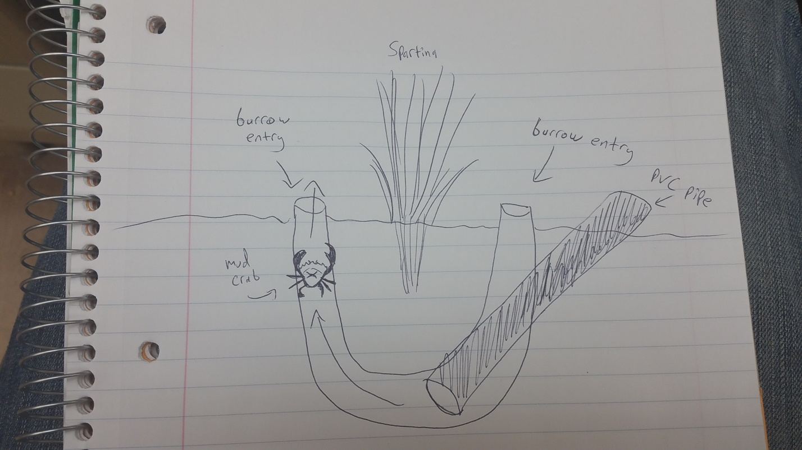

**Appendix B**

**Table 1.** This table displays all parameters recorded for each trial. Note, at 30OC, an additional male was mistakenly used in place of a female (Male 2-3).

