Title
Role of biogenic structure in mediating predation: does cordgrass get in the way of crabs searching for mussels?
K. Martin Perales – Problems in Oceanography 2015
Abstract
An organisms’ local distribution is a function of the biotic and abiotic conditions encountered. Positive interactions and/or associations with other species may expand an organism’s range. One positive interaction that may be especially important to expanding a sessile organisms’ distribution is the mediation of predation pressure by biogenic structure. For sessile organisms that cannot flee from predators, the creation of refuge habitat by other organisms can be a critical form of positive interaction. I designed an experimental field manipulation in conjunction with an observational field survey to investigate the role of smooth cordgrass in mediating predation of ribbed mussels by blue crabs. Blue crabs were placed in predator enclosures with contrasting smooth cordgrass density. Number of mussels consumed were counted after each predation trial. Results from the experimental predator enclosures were inconclusive due to a low number of mussel mortalities. To understand the distribution of mussels, number of mussel beds were counted along transects. Remote sensing data was used to evaluate the importance of elevation above sea level, distance from creek as an index of predation, and an index of smooth cordgrass biomass in dictating distribution. Number of mussel beds from the field survey had significant quadratic relationships with an index of cordgrass biomass and distance from the creek. This suggests that there is an optimal location for the highest number of mussel beds. It is likely the case that predation is pushing the distribution of ribbed mussels away from optimal abiotic conditions. Whether or not cordgrass reduces this push is unclear from this data set.
Introduction
The idea that an organism has a specific niche, and as a result, a specific distribution is an old concept in ecology (Grinnel 1917). An organism’s local distribution can largely be interpreted as a function of interspecific competition, predator-prey dynamics and habitat suitability. For example, predation can shrink or move an organism’s distribution (Seed 1980). If predation pressure is relaxed or removed, an organism’s distribution can expand until environmental suitability becomes the dominant structuring component (Lewis and Eby 2002). Furthermore, organisms are competing for space and resources. The strong zonation patterns in Atlantic coast salt marshes is the result of less than ideal abiotic conditions (e.g., soil conditions, desiccation stress, inundation time, etc.) but competition or predation can also play a significant role. Saltmeadow cordgrass Spartina patens is competitively dominant over smooth cordgrass Spartina alterniflora (hereafter S. alterniflora). This competition often results in shrinking the distribution of S. alterniflora (Bertness 2007). Positive interactions have gotten less attention from ecologists but can also play significant roles in dictating an organism’s local distribution (Bertness & Callaway 1994).
Recently, several studies in Atlantic coast salt marshes have investigated the importance of positive interactions in ameliorating either abiotic or biotic stress. Angelini et al. (2015) demonstrated that the overlap of S. alterniflora and mussels increased niche space, thus facilitating coexistence of more invertebrate functional groups. The increased spatial complexity created with the overlap of these species can be interpreted as positive interactions ameliorating interspecific competition. S. alterniflora has also been shown to ameliorate environmental stress by shading the substrate, which leads to a reduction in thermal and desiccation stress on organisms. Additionally, S. alterniflora reduced predation mortality of several sympatric species (Crotty & Bertness 2015). Sessile organisms are especially vulnerable to predators because they cannot flee. Any mediation of predation via positive interactions or associations with other species such as S. alterniflora could potentially alter the population abundance and distribution of mussels (Gosselin & Qian 1997).
There are many examples of sessile organisms having positive interactions with organisms that create biogenic structure which mediate predation. Blunden and Kennedy (1982) experimentally demonstrated that predation success of blue crabs on soft-shell clam Aya arenaria was significantly reduced by the presence of an artificial mimic of redhead grass Potamageton perfoliatus. It is also possible that the presence of structural refuges can facilitate successful spat settlement of bivalves (Bertness & Grosholz 1985). Furthermore, it has been demonstrated that predation of Geukensia demissa ribbed mussels (hereafter mussels) by xanthid mud crabs is reduced on American oyster Crassostrea virginica reefs (Lee & Kneib 1994). This suggests that the expansion of an organism’s local distribution can be facilitated by the presence of biogenic structure which acts as predation refuge (Crotty & Bertness 2015).
Given the potential for S .alterniflora to mitigate predation, I conducted an experimental manipulation in the field and an observational field survey in an Atlantic salt marsh to test the prediction that biogenic material can mediate predation pressure on mussels. Mussels are semi-infaunal and are typical of regularly flooded marshes and mud flats. They often form dense aggregations that are associated with S. alterniflora roots. Mussels are active filter feeders that require being inundated regularly (Bertness 2007). Two hypotheses are tested in this study. 1) S. alterniflora acts as a refuge for mussels and reduces predation by blue crabs Callinectes sapidus. Feeding trials with blue crabs in enclosures with contrasting S. alterniflora density were used to test this. 2) The number of mussel beds would increase with S. alterniflora. This was investigated with an observational field survey using remote sensing data.
Methods
Study site
Dean Creek is a tidal creek located within the Sapelo Island National Estuarine Reserve on Sapelo Island, Georgia. The marsh adjacent to Dean Creek, hereafter Dean Creek marsh, is dominated by S. alterniflora. All field work was conducted October 24-30, 2015. Previous studies have found that mussels in Dean Creek marsh are larger and are more widely dispersed in more densely aggregated beds as compared to nearby Lighthouse marsh (Sanderson 1993). Furthermore, mussels in Dean Creek marsh are distributed further inland, in respects to the main tidal creek, then in Lighthouse marsh.
Predation experiment
Predator enclosure
To quantify the role of S. alterniflora in mediating predation pressure on ribbed mussels, I placed four experimental cages on the low marsh in Dean Creek marsh (Figure 1.). Cages were 1x1x1 meters and constructed of green mesh shade cloth and bamboo poles. An effort was made to select sites with comparable mussel and S. alterniflora stem densities. Stakes were used to keep edges flush with the ground. Marsh periwinkles Littoraria irrorata and xanthid mud crabs were removed from enclosures before beginning the experiments. S. alterniflora stems were counted, along with mussels. To effectively quantify mussel density in the enclosures, I felt along the mud and counted the number of ridges I encountered. Density of mussels ranged from 49 to 60 individuals/m² and density of S. alterniflora stems ranged from 370 to 475 stems/m². Two of the four cages were randomly selected for removal of all S. alterniflora stems with scissors. The other two cages were left un-altered.
Blue crab feeding trials
Blue crabs were captured from Dean and Lighthouse creek using conventional blue crab traps. Crabs were starved for 24-48 hours prior to trials. A total of 11 feeding trials were run; 5 with female crabs and 6 with male crabs. Carapace width was measured to the nearest millimeter (mm) from the tip to tip of the lateral spines. Crabs ranged in size from 118 to 170 mm (mean = 154.5 mm). A single crab was placed in each pen during mid flood for roughly 4 hours. I recorded the number of and length mussels that were consumed after the crab was removed.
Mussel bed spatial distribution
Line transect surveys for mussel beds
To assess the spatial distribution of ribbed mussel beds in Dean Creek marsh with respect to metrics of habitat quality, mussel beds were counted in contiguous five m² quadrats along ten transects. Transects ranged from 75 to 95 meters long and were oriented perpendicular to Dean Creek, starting just south of Beach Road. Each quadrat extended 5 m along the transect, and was 1 m wide. The location of the end and the beginning of transects were marked with either an iPhone 5s using the MotionX-GPS app or a Garmin eTrex handheld GPS. Location of beginning or end was manually corrected the following day if the marked position was deemed too inaccurate. A surveying tape was used to measure the length of the transect. At the upper marsh end of each transects, the final quadrat occurred at the transition from S. alterniflora to other vegetation. Carrying a meter stick, I walked along the survey tape and counted the number of mussel beds within 0.5 meters of either side of me for every 5 meters, until the end of the transect was reached. Half meter search distance was chosen to ensure complete detection of mussel beds. Reported numbers of mussel beds are in number of mussel beds per five square meters, and any mussel observed within 20 cm of another one was considered to represent the same bed. The number of mussels within each bed was not recorded.
Spartina alterniflora distribution
Existing remote sensing data was used to understand the spatial distribution of relative S. alterniflora density. Airborne Imaging Spectrometer was used to acquire one meter resolution hyperspectral images on June 20-21, 2006 (Hladik 2006). A Normalized Difference Vegetation Index (NDVI) was calculated using the near infrared and red band intensities ((NIR799 – RED675)/(NIR799 + RED675)). NDVI has been used in many studies as an index of the relative amount of photosynthetic activity (Huete et al. 2002). To facilitate interpretation of the NDVI index, I calculated above ground dry weight biomass (g/m²) of S. alterniflora using the formula (153.8*X) + (5,525*X²) – (4,077*X³) + (7,624*X⁴) from Schalles et al. (2013), where X is the NDVI index. However, statistical modeling of mussel bed densities focused on NDVI itself rather than estimated biomass to avoid problems from nonlinear transformation in a GLMM. The area of interest was extracted using a mask in ArcGIS 10.3.1 (ArcToolbox > Spatial Analyst Tools > Extract by Mask Tool) and re-georeferenced to increase accuracy for the study site. Surveyed bins were converted to points at the centroid to facilitate extraction of values from rasters (ArcToolbox > Spatial Analyst Tools > Extract Values to Points).
Elevation above sea level as index of inundation time
Elevation is used as a relative measure of inundation time, thus another proxy for habitat quality that pertains to feeding opportunities for mussels. Mussels are active filter feeders and benefit from longer inundation time. Elevation was extracted using a similar process as NDVI, from an existing three meter resolution LiDAR derived digital elevation model (Carpenter 2008). The vertical resolution is around a centimeter and max error is less then +/- 0.3m. Qualitatively, the digital elevation model seemed to capture the elevation patterns observed while surveying mussel beds. Data was collected from December 2005 to February 2006 by the Joint Airborne Lidar Bathymetry Technical Center of Expertise.
Distance from Dean Creek
Distance from the edge of Dean Creek was calculated using ArcMap. Distance from creek to the points at the centroid of the transect quadrat was calculated using the Near function in ArcMap (ArcToolBox > Analysis > Near). This is an important predictor variable because it acts as a proxy for predation pressure. Typically, predation is highest at the tidal creek and decreases with distance from the creek (Lin 1989).
Statistical analysis
For predation experiments, the mean number of mussels predated on was compared between the two treatments (S. alterniflora intact, S. alterniflora removed) using a t-test. The mussel bed distribution data were analyzed using standard statistical techniques for count data with many zeroes; Poisson regressions with random effects were used. The response variables (#mussel beds/5m²) were left as integers so that a Poisson regression could be used. Predictor variables were standardized by subtracting the mean and dividing by the standard deviation (transformed into a z-score). The three predictor variables we are interested in are elevation above sea level (E), NDVI (N) and distance from Dean Creek (D).
The three predictor variables were plotted to investigate and eliminate multi-collinearity between independent variables before models were tested. A correlation coefficient absolute value of 0.5 was chosen as the cut off to exclude variables from models to avoid issues derived from multi-collinearity. Elevation above sea level was highly correlated with distance from Dean Creek (Pearson correlation coefficient = -0.61, P < 0.001) and with NDVI (Pearson correlation coefficient = 0.69, P < 0.001).
I was interested in linear and quadratic relationships between the three independent variables and mussel bed distribution. Due to a high level of correlation between E and the other two variables, E was tested by itself with linear and quadratic coefficients. Every combination of N and D with linear and quadratic coefficients were tested. This resulted in a total of 11 models. Akaike information criterion (AIC) was used to select the final model with a Delta AIC value of at least 2 being considered a real difference. All compared models had quadrat (ID) as a random effect. Statistical analysis was done in R.
Results
Predation experiment
There was a single predation event in the blue crab enclosures. A large female (carapace width = 161 mm) consumed a single mussel with a length of 54 mm in an enclosure without S. alterniflora. Means were not significantly different between S. alterniflora intact and S. alterniflora removed treatments (two-sample t-tests, P = 0.3632).
Mussel bed spatial distribution
Using AIC as my selection criteria, the model including N and D with both linear and quadratic coefficients performed better than all other options (Table 1). The fitted coefficients suggest that there is a negative quadratic relationship between each independent variable (N and D) and mussel bed density. This negative quadratic relationship means that mussel beds increase until a certain point, and then decrease (Figure 2, 3). Thus, the highest number of mussel beds are associated with intermediate values for both N and D. To find the value the model predicts to be the highest number of mussel beds for N and D, I used the formula –b/2a. The b term is the linear coefficient and a is the quadratic coefficient for either N or D from the model. This was done separately for N and for D. Values were transformed from Z-scored values to real values by multiplying by standard deviation and adding the mean. The model suggests that the highest number of mussel beds occur at 42.75 meters from Dean Creek and where NDVI values are 0.238. This optimal NDVI value corresponds to an above ground dry weight biomass value of 318.59 g/m².
Discussion
My study does not fully resolve the role of S. alterniflora in mediating predation pressure by blue crabs on ribbed mussels. The number of mussels consumed in experimental manipulation of S. alterniflora stem density in predator enclosures was not significantly different. There was only a single predation event out of 11 trials and it occurred in a S. alterniflora removed treatment enclosure. Although the number of predation events was extremely low, it did meet our expectation of which treatment it would happen in. A large female blue crab was the only crab to consume a mussel. This is significant based on recent results of experimental predation trials with blue crabs on two smaller mud crab species (Stevens 2015). Results of the study strongly suggest that females were much more aggressive than males while I was at Sapelo Island, thus advocating that male and females be treated separately. Unfortunately, I had a small sample size when looking at just predation trials with females (3 trials with S. alterniflora removed, 2 trials with S. alterniflora intact). While the difference in predation pressure in the two treatments with female crabs is not statistically significant, it is possible I would have found a significant difference with a larger sample size.
There are many possibilities as to why the experiment was inconclusive. The blue crabs only had four hours in the enclosure. Much of this time was likely spent acclimating to a new environment. Additionally, feeding trials were done during the high tide that occurred at night. Not enough is known about the foraging behavior of blue crabs to say whether this exacerbated or helped with acclimation. When blue crabs were retrieved at the end of a feeding trial, the crabs were partially buried in the mud. It is not known how long the crabs were buried or if leaving the crabs in for 24 hours to allow for acclimation would have been better. Furthermore, it was difficult to isolate blue crabs in the holding facility. This overcrowding during the starvation period may have stressed our blue crabs, leading to not feeding effectively.
Previous studies investigating the impact of predation by blue and xanthid crabs on ribbed mussels were not fully consistent. Some studies have shown high predation mortality while others conclude that blue crabs show low preference for mussels (Lin 1989, West & Williams 1986). In one study, S. alterniflora density along with the density for three prey species were manipulated and enclosed with a blue crab. These included mussels, marsh periwinkles and mummichog Fundulus heteroclitus. The authors concluded that there was low preference for mussels compared to the other two prey species. This resulted in extremely low mortality for mussels. This suggests that mussels are more difficult to consume then are mummichogs or marsh periwinkles when enclosed together (West & Williams 1986). Lin (1989) demonstrated extremely high predation pressure on mussels; mortality rates in experimental units ranged from 15% to 50% in the high and low marsh, respectively. Moreover, Seed (1980) concluded that the distribution of mussels could be interpreted as the predatory activity of crabs based on lab feeding trials, where crabs consumed large numbers of isolated mussels.
The results from the Poisson regression suggest that the highest number of mussel beds is associated with an intermediate value for distance from Dean Creek (42.75 m; Figure 2). This suggests that conditions near and far from the creek are suboptimal. This could be the case for many reasons. Upland predators could be pushing the distribution closer to the creek. While surveying, I saw footprints and scat left behind, mainly by raccoons Procyon lotor and American white ibis Eudocimus albus. Elevation as an index for inundation time is also important to consider. It is assumed that mussels grow better the longer they are inundated due to increased time feeding. Elevation in Dean Creek marsh decreases with distance from the creek (Figure 5); consequently, mussel beds closest to the edge of the tidal creek are being inundated for shorter periods of time as compared to mussel beds further away. Thus, the habitat that is inundated the longest also has the easiest access by upland predators.
These regions of the marsh lowest in the landscape tended to have low NDVI values. NDVI in Dean Creek marsh tends to be highest at the creek edge and decreases with distance from the creek (Figure 4). The highest number of mussel beds was associated with an intermediate value of 0.238 NDVI (Figure 3). NDVI values ranged from 0.117 and 0.517, which is equivalent to biomass values of 88.5 and 1537.6 above ground dry weight biomass (g/m²), respectively. The area with the highest S. alterniflora biomass is also where predators from the creek have the shortest travel distances. The most plausible explanation for why distance from the creek and NDVI are negative quadratic relationships is because, mussels are integrating optimal habitat conditions (i.e., S. alterniflora as refuge and inundation time) and predation pressure. There are multiple gradients present structuring mussel distribution. Upland predators and predators from the creek are squeezing the local distribution of mussel beds into a longitudinal band along Dean Creek. Habitat with the longest inundation time and habitat with the highest potential for S. alterniflora to act as predation refuge are at opposite ends.
It is unclear if S. alterniflora acts as predation refuge for mussels. It may be the case that S. alterniflora does not mediate predation enough to detect a pattern with this data set. However, we could easily imagine either S. alternifora stems or roots protecting mussels in all life stages. The modeled relationship between mussel bed distribution and the three measured predictor variables may also be specific to Dean Creek marsh. It is risky to generalize without a comparative element. In future studies, a comparison between several marshes with different combinations of S. alterniflora density and topography should be included.
Suggestions for future Sapelo students
- The main piece of advice is to be nimble. Your project will have hiccups.
- Build everything at CFL. I needed predator enclosures and I improvised them there. Big time sink. Had I built them at the CFL, they would have been better and faster to set up.
- Try and figure something to do on the beach. The marsh is awesome but can be a challenging place to work. If you are hell bent on working in the marsh, bring a couple of pairs of nitrile gloves to protect against Spartina, bug net, beer, headphones, long sleeves and knee high boots.
- Also, if I could do Sapelo again, I would try and use someone’s published model or data to simplify my field work. The truth is you don’t have much time. For example, I found out after the fact that Angelini et al. 2015 has a model that estimates the number of mussels in a mussel bed based solely on the measuring the area of the mussel bed. I used some remote sensing data that had NDVI (you can derive biomass from this index, see methods). This can save you an immense amount of time if you can find this sort of information before hand. Capitalize on this sort of thing.
- Another piece of good advice is to do a quick survey before starting your project. I set my experiment up before understanding the spatial distribution of mussels. I think I would have looked at the available remote sensing data to get a sense of how vegetation and elevation are distributed along Dean Creek marsh. A survey covering marshes with different configurations would make for a good comparison. Furthermore, I had a 166 quadrats for one marsh. That sample size was more than adequate and it only took around 5 hours to collect by myself. If you measured the mussel beds (to get number of individuals) and did this same sort of survey for several areas, you would have a robust project. Questions like how do number of mussel beds and number of mussels change along predation, elevation or vegetation density gradients? Do they change equally or are they inversely related? It could be the case that the mussel beds near the creek are bigger. Worth digging into.

References
Angelini, C., T. van der Heide, J. N. Griffin, J. P. Morton, M. Derksen-Hooijberg, L. P. M. Lamers, A. J. P. Smolders, and B. R. Silliman. 2015. Foundation Species’ Overlap Enhances Biodiversity and Multifunctionality from the Patch to Landscape Scale in Southeastern United States Salt Marshes. Proceedings of the Royal Society B: Biological Sciences. 282: 1811
Bertness, M. D. 2007. Atlantic shorelines: natural history and ecology. Princton: Princeton University Press.
Bertness, M. D. 1984. Ribbed Mussels and Spartina Alterniflora Production in a New England Salt Marsh. Ecology. 65: 1794-1807.
Bertness, M. D., and E. Grosholz. 1985. Population Dynamics of the Ribbed Mussel, Geukensia Demissa: The Costs and Benefits of an Aggregated Distribution. Oecologia. 67: 192–204.
Bertness, M. D., and R. Callaway. 1994. Positive interactions in communities. Trends in Ecology and Evolution 9:191–193.
Blundon, J. A. and V. S. Kennedy. 1982. Mechanical and behavioral aspects of blue crab, Callinectes sapidus (Rathbun), predation on Chesapeak Bay bivalves. J. Exp. Mar. Bioi. Ecol. 65:47-65.
Carpenter, J. 2008. NOAA LiDAR. Georgia Coastal Ecosystems LTER File Archive, University of Georgia, Athens, Georgia. (http://gce-lter.marsci.uga.edu/public/app/resource_details.asp?id=300)
Crotty, S. M., and Mark D. Bertness. 2015. Positive Interactions Expand Habitat Use and the Realized Niches of Sympatric Species. Ecology. 96: 2575–2582.
Gosselin, L. A., and P. Qian. 1997. Juvenile Mortality in Benthic Marine Invertebrates. Marine Ecology Progress Series. 146: 265–82.
Grinnell, J. 1917. The Niche-Relationships of the California Thrasher. The Auk. 34: 427–33.
Hladik, C. M. 2013. 2006 AISA hyperspectral imagery of the GCE domain for vegetation. Georgia Coastal Ecosystems LTER Project; Georgia Southern University; Long Term Ecological Research Network.http://dx.doi.org/10.6073/pasta/09075b66ccf91a0c87ffbd113f754977
Huete, A., K. Didan, T. Miura, E. P. Rodriguez, X. Gao, and L. G. Ferreira. 2002. Overview of the Radiometric and Biophysical Performance of the MODIS Vegetation Indices. Remote Sensing of Environment. 83: 195–213.
Jordan, T. E., and Ivan Valiela. 1982. A Nitrogen Budget of the Ribbed Mussel, Geukensia Demissa, and Its Significance in Nitrogen Flow in a New England Salt marsh1. Limnology and Oceanography. 27: 75–90.
Lee, S. Y., and R. T. Kneib. 1994. EFFECTS OF BIOGENIC STRUCTURE ON PREY CONSUMPTION BY THE XANTHID CRABS EURYTIUM-LIMOSUM AND PANOPEUS-HERBSTII IN A SALT-MARSH. Marine Ecology Progress Series. 104: 39–47.
Lewis, D. B., and L. A. Eby. 2002. Spatially Heterogeneous Refugia and Predation Risk in Intertidal Salt Marshes. Oikos. 96: 119–29.
Lin, J. 1994. Influence of location in a salt marsh on survivorship of ribbed mussels. Marine Ecology Progress Series. 105: 39–47.
Sanderson, B. 1993. Ecology and distribution of the ribbed mussel along a tidal elevation gradient: roles of predation, submergence time, and Spartina. University of Wisconsin Madison.
Schalles, J, C. Hladik, A. Lynes, and S. Pennings. 2013. Landscape Estimates of Habitat Types, Plant Biomass, and Invertebrate Densities in a Georgia Salt Marsh. Oceanography 26. 3: 88–97.
Seed, R. 1980. Predator-prey relationships between the mud crab Panopeus herbstii, the blue crab Callinectes sapidus and the Atlantic ribbed mussel Geukensia demissa. Est. Coast. Mar. Sci. 11:445-458.
Stevens, A. 2015. Temperature influences on crab predation: an interesting consideration for biotic resistance to invaders. University of Wisconsin Madison.
Stiven, A. E., and E. J. Kuenzler. 1979. The Response of Two Salt Marsh Molluscs, Littorina Irrorata and Geukensia Demissa, to Field Manipulations of Density and Spartina Litter. Ecological Monographs. 49: 151-171.
West, D. L. and A. H. Williams. 1986. Predation by Callinectes sapidus (Rathburn) within Spartina alterniflora (Loisel) marshes. J. Exp. Mar. Bioi. Ecol. 100: 75-95.

List of Figures and Tables
Figure 1. Site map of Dean Creek marsh showing the location of predator inclosures and mussel bed survey transects.
Figure 2. Relationship between number of mussel beds/5m² and distance from Dean Creek. GLMM model results plotted keeping other significant coefficients constant.
Figure 3. Relationship between number of mussel beds/5m² and NDVI. GLMM model results plotted keeping other significant coefficients constant.
Figure 4. Relationship between number of NDVI and distance from Dean Creek (m).
Figure 5. Relationship between number of elevation (m) and distance from Dean Creek (m).
Table 1. Shows models that were tested and results. Model with lowest AIC was chosen. AIC = Akaike information criterion. Delta AIC = AIC of best model – rest of models. DF = Degrees of freedom.
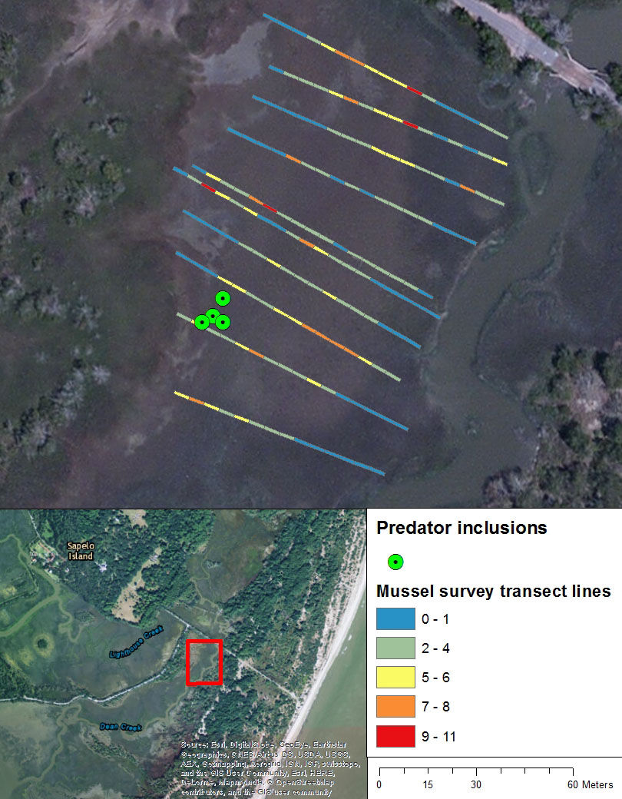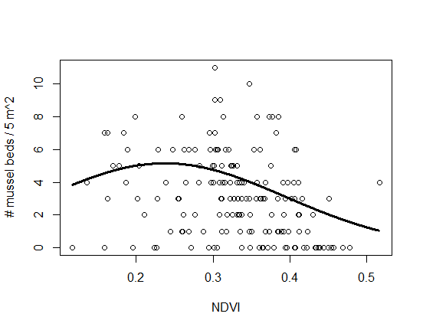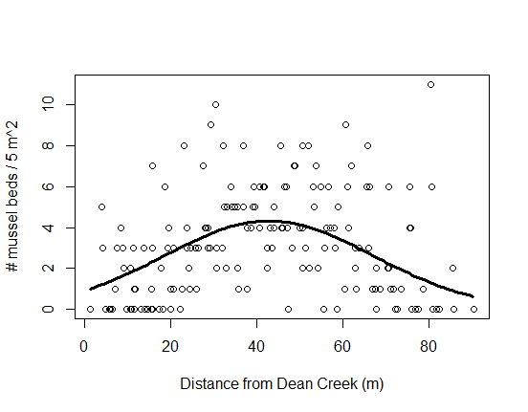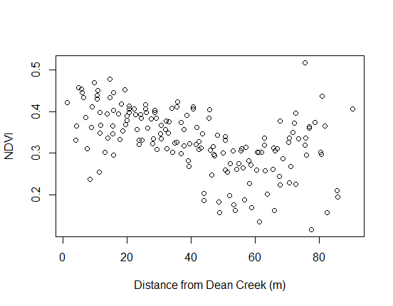
Number of mussels/5 m²
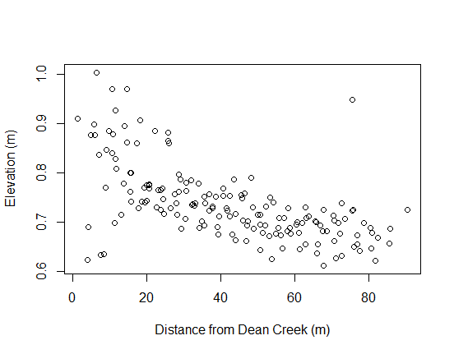

Model | AIC | Delta AIC | DF
Mussel_bed ~ N + D + I(N^2) + I(D^2) + (1 | ID) | 703.96 | 0 | 6
Mussel_bed ~ N + +D + I(D^2) + (1 | ID) | 707.23 | 3.27 | 5
Mussel_bed ~ D + I(D^2) + (1 | ID) | 711.9 | 7.94 | 4
Mussel_bed ~ E + I(E^2) + (1 | ID) | 719.99 | 16.03 | 4
Mussel_bed ~ N + I(N^2) + (1 | ID) | 736.4 | 32.44 | 4
Mussel_bed ~ E + (1 | ID) | 737.38 | 33.42 | 3
Mussel_bed ~ N + D + I(N^2) + (1 | ID) | 737.5 | 33.54 | 5
Mussel_bed ~ N + (1 | ID) | 745.62 | 41.66 | 3
Mussel_bed ~ N + D + (1 | ID) | 747.07 | 43.11 | 4
Mussel_bed ~ 1 + (1 | ID) | 759.28 | 55.32 | 2
Mussel_bed ~ D + (1 | ID) | 759.83 | 55.87 | 3

